05/15/2019

CSC 343, SPRING-2019

Single cycle cpu-lite

Lab#5 Professor: izidor gertenr

Presented by: Hasibul Islam

Due: May 15,2019

# Single cycle cpu-lite

## Objective -------------------------------------------------

## Design-------------------------------------------------

## Design of the circuit-------------------------

## 3 ported ram----------------------------------------

## Bitwise operation---------------------------------

## Integration of everything

## De2 board

## Conclusion------------------------------------------------------

## Objective

This lab is to develop and test a Single Cycle CPU that is going to perform computations within one clock cycle, based on the input instructions. These instructions will be consisting of MIPS instruction set. The instruction set will be 32-bit long consisting of R and I format which will be having the values for operands, the location of the operands stored

## Desgin

* register has been used to store the 32-bit wide
* addition, subtraction, multiplication, division, and, or, xor, nor, comparison, immediate addition, and immediate subtraction

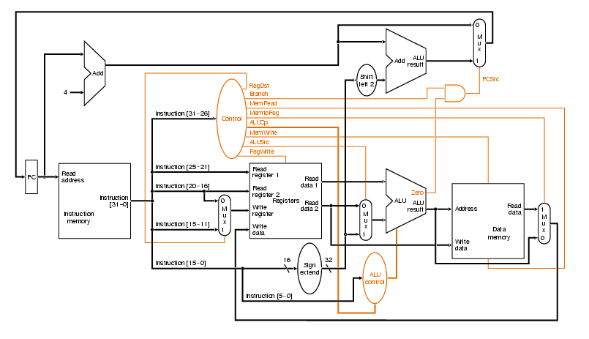

## Design of the circuit

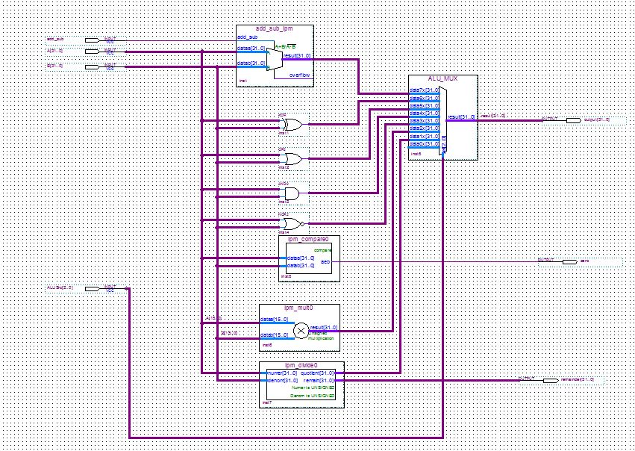

## 3 ported ram

* ram has been constructed through VHDL codes

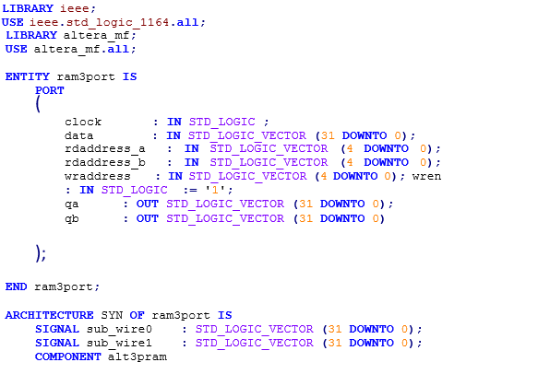

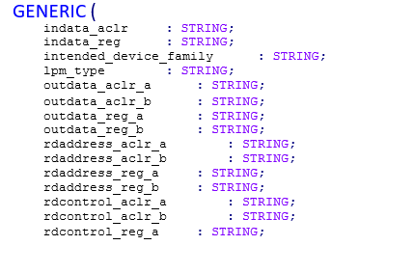

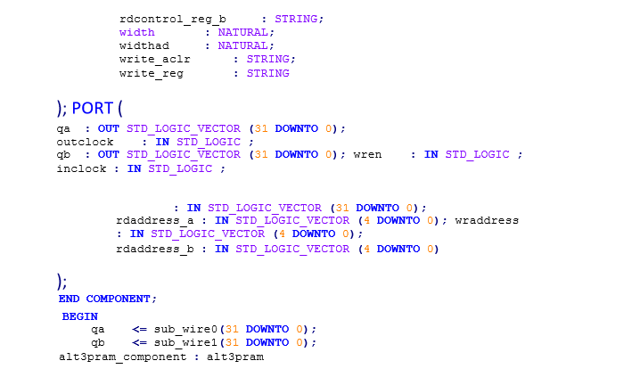

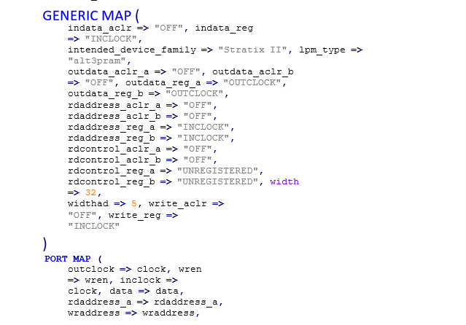

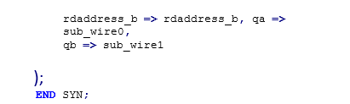

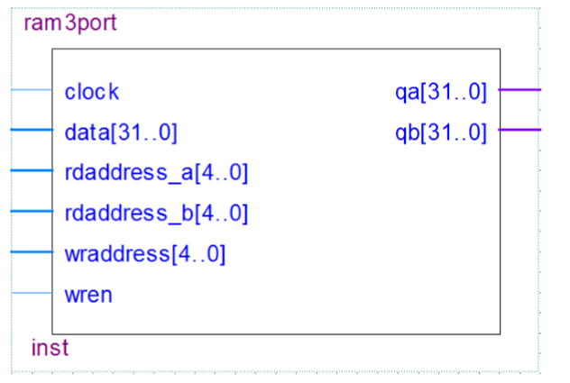

## Bitwise operation

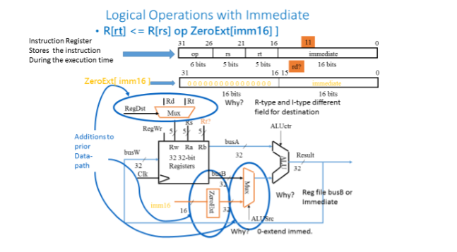

## Integration of Everything

* integrate them together the way it is displayed on
* in Quartus the Single Cycle CPU

## DE2 Board

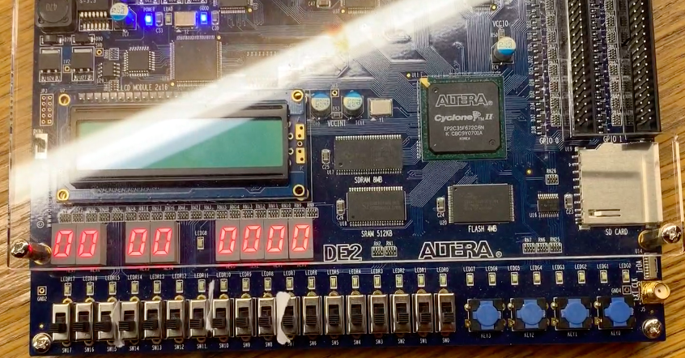

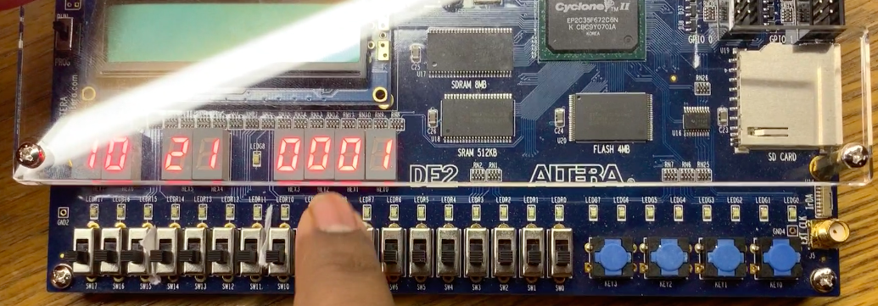

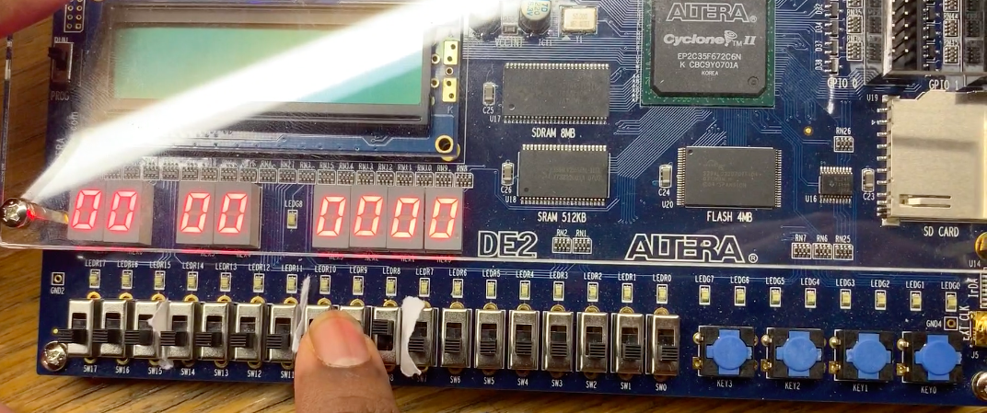

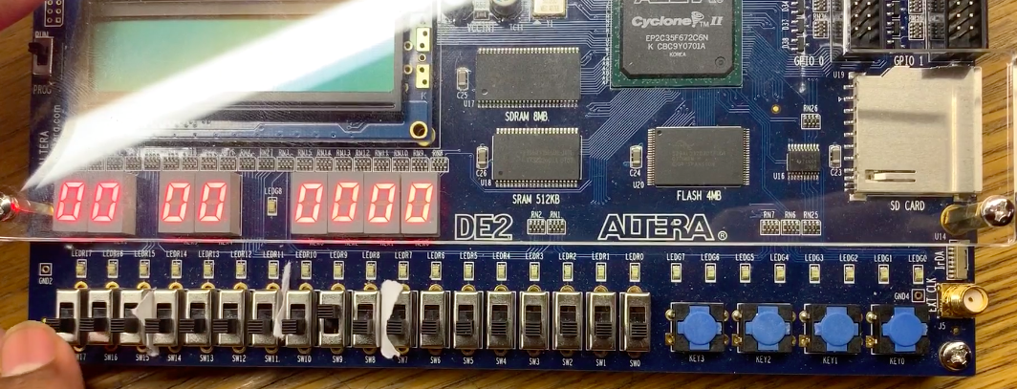

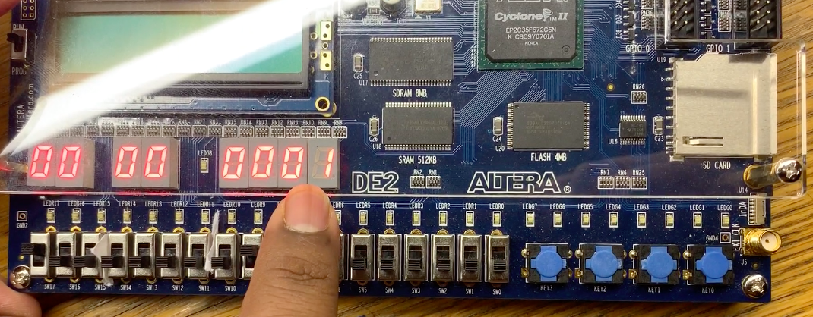

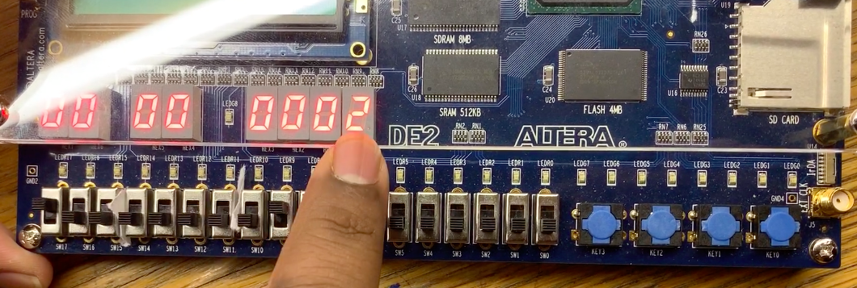

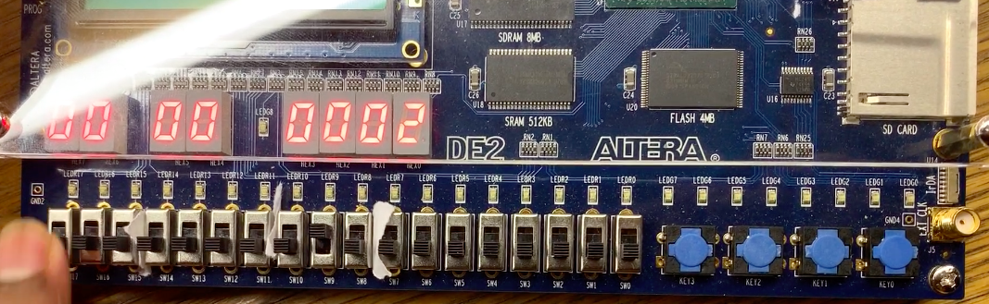



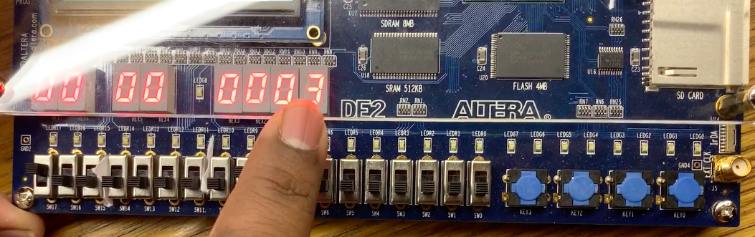

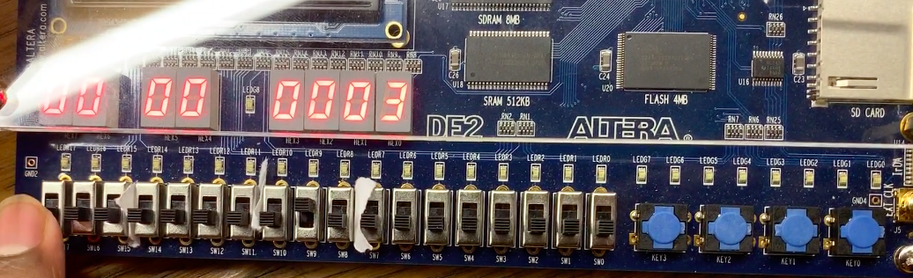

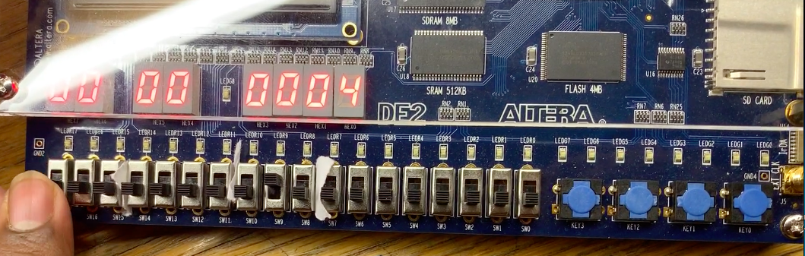

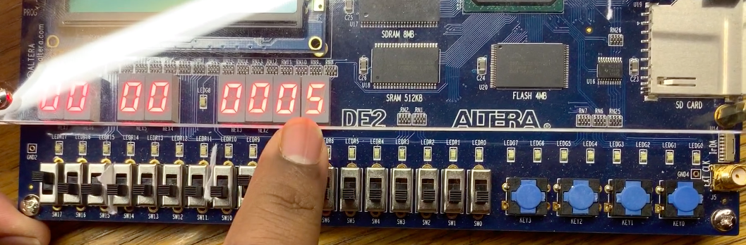

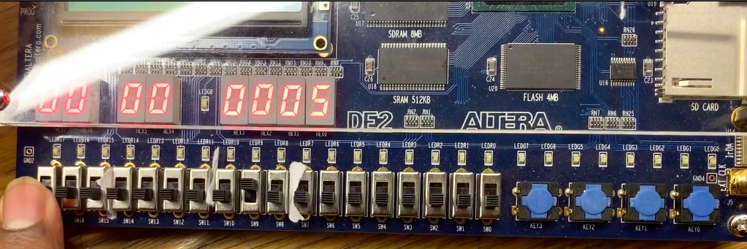

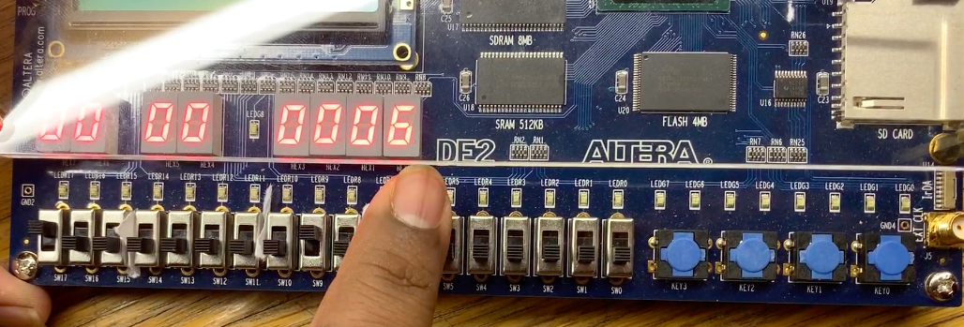

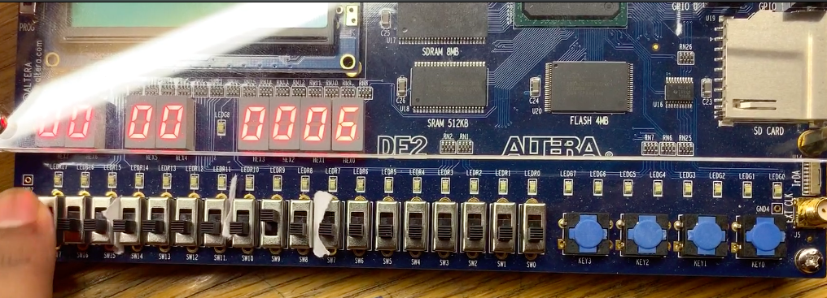

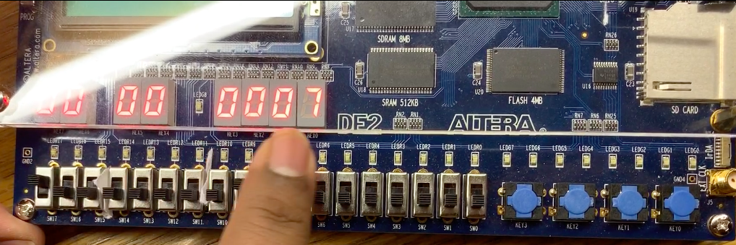

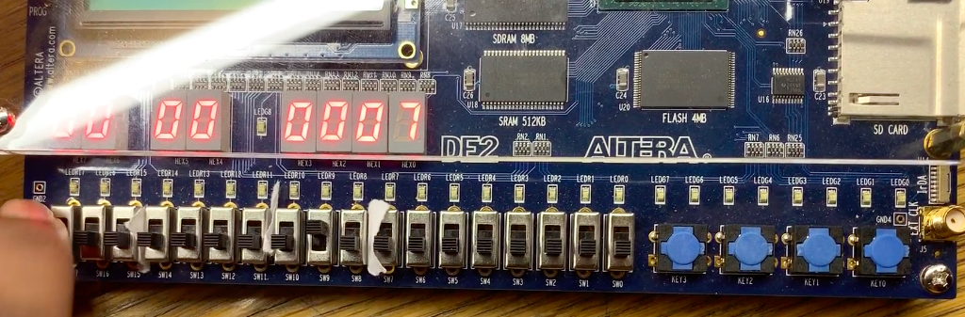

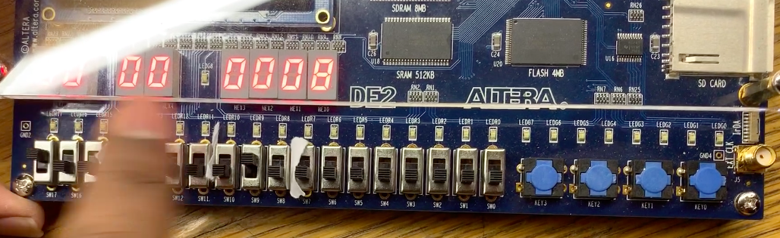

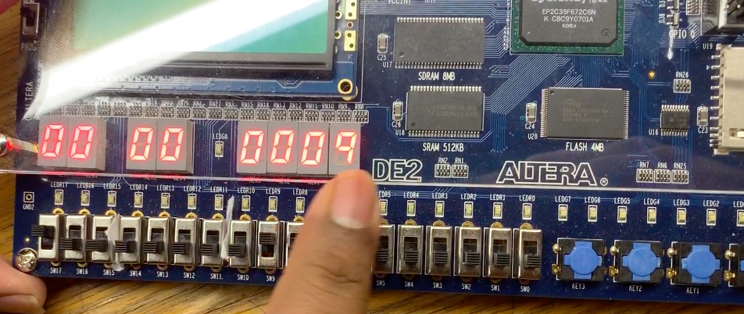

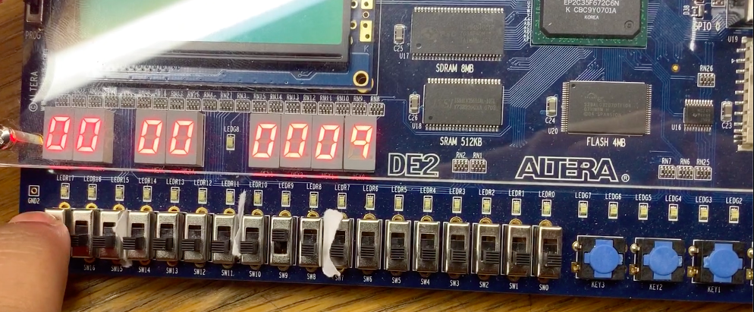

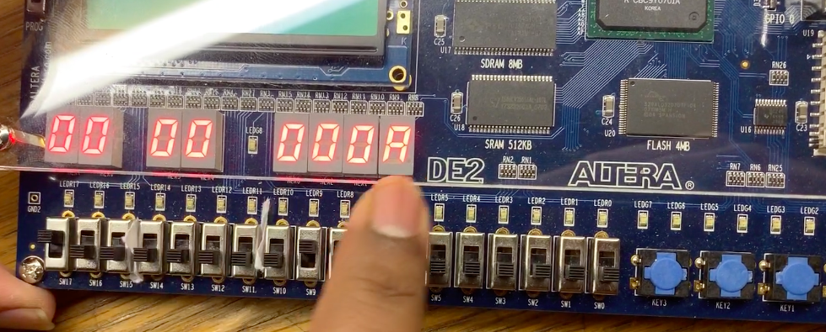

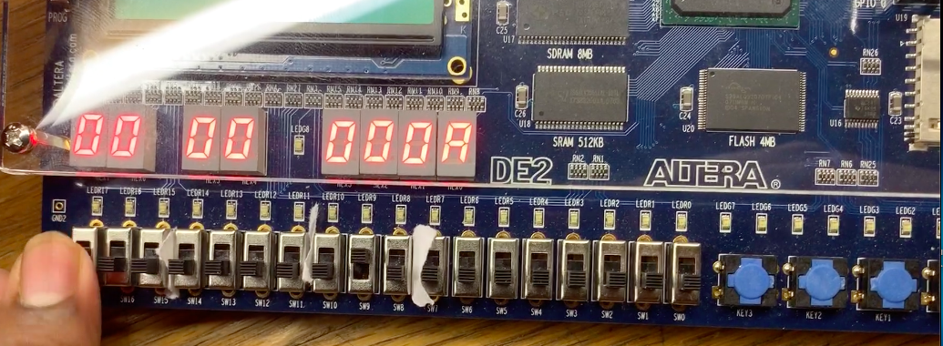

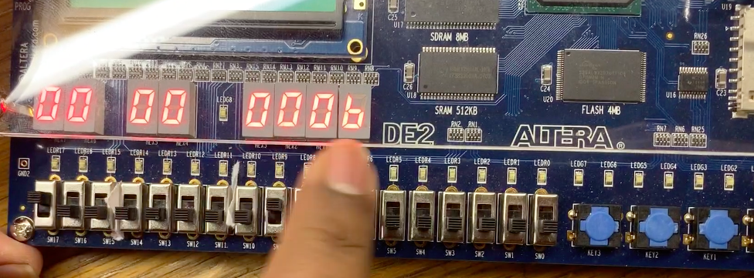

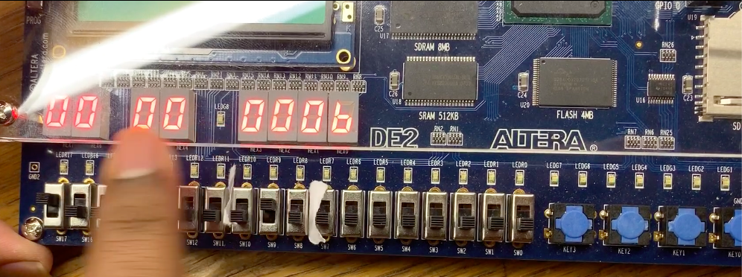

Conclusion

In this lab was the most challenging of all the lab. The implementation of MIPS Instruction set into the single cycle CPU makes it a real time CPU. And overall of this doing it, I have learned a lot from designing this Single Cycle CPU.